

**Language Instruction Education Program for English Language Learners Handbook**

Hmong College Prep Academy

1515 Brewster Street

St. Paul, Minnesota 55108

Updated June 2023

**Table of Contents**

**Mission and Values Statement 2**

**Legal Foundations 4**

**Definitions 7**

**Identifying Students as EL 9**

**Minnesota Standardized English Learner Identification and Entrance Procedure 11**

**Minnesota Home Language Survey 14**

**Parent and Guardian Rights 14**

**English Learner Exit Criteria and Procedures 15**

**Scope and Sequence of English Language Services 17**

**Appendix A 21**

**Appendix B 22**

**Appendix C 24**

**Appendix D 25**

**Appendix E 26**

**References 27**

# *Mission and Values Statement*

Hmong College Prep Academy’s mission is to provide the best integrated, challenging, and well-rounded educational experience to students in grades K-12.  
HCPA will accomplish its mission at all grade levels via adhering to its core values:  
***Warrior Way***Warriors at Hmong College Prep Academy embody a growth mindset that fosters the development of discovery and perseverance throughout their lives. Warriors follow the Warrior Code to demonstrate how they Respect Self, Respect Others, and Respect their Community.  
***Relationships and Connections***Hmong College Prep Academy provides a safe learning environment where relationships are fostered to build connections based on mutual trust between students, staff, and the community.  
***Commitment to Excellence***Through a student-centered mindset, Hmong College Prep Academy welcomes challenging opportunities that promote investigation, hands-on learning, and independence to grow a community of learners.  
***College and Career***Hmong College Prep Academy Warriors consistently engage with college and career exploration that focuses on the social and emotional development of the whole child. The moral development and academic rigor of the college and career focus prepares the Warriors to look beyond the K-12 environment.  
***Global Perspective***Warriors embark on a mission to discover the world around them. Through curiosity and exploration Warriors become aware of the global impact of their decisions, taking on new information with an open and engaged mind, instilling lifelong learning.  
***The Result***  
HCPA graduates will be rich in experiences, culture, knowledge, & pride and ready for the challenges of college and beyond.

**Asset-Based Language**

Hmong College Prep Academy district uses student-first, asset-focused language that prioritizes students’ strengths and potential. Using asset-based language allows us to focus on the student attributes and strengths that they bring into the classroom environment, rather than focusing on their deficit and defining the student by which services they receive (e.g., special education, math or reading interventions, etc.) that allow for a generalization of the student.

# Legal Foundations

A number of key documents detail the federal and state requirements for the education of English language learners.

**Federal**

***Title VI, Civil Rights Act 1964***

No person in the United States shall, on the grounds of race, color, or national origin be excluded from participation in, be denied the beliefs of, or otherwise be subjected to discrimination under any program or activity receiving federal financial assistance from the Department of Health, Education, and Welfare.

***The Bilingual Education Act, 168 (Amended in 1974 and 1978)***

In order to establish equal educational opportunity for all children, Congress declared that the policy of the United States would be as follows: (a) to encourage the establishment and operation, where appropriate, of educational programs that use Bilingual educational practices, techniques, and methods; and (b) for that purpose, to provide financial assistance to local education agencies, and to state agencies for certain purposes.

***Equal Education Opportunities Act of 1974***

This law requires that students not be denied access to educational opportunities based on race, color, sex, or national origin and requires public schools to provide for students who do not speak English.

***Lau v. Nichols, 1974***

A case in which The U.S. Supreme Court ruled that under the Civil Rights Act of 1964 a school receiving federal funds must provide non-English speaking students with instruction in the English language to ensure they receive an equal education opportunity.

***Castenada v. Pickford, 1981***

The major outcome of this case was a set of three guidelines to use to evaluate programming for English language learners (ELs):

* + Is the program theoretically sound or experimentally appropriate?
  + Is the program set up in a way that allows this theory to be put in practice?
  + Is the program regularly evaluated and adjusted to ensure that it is meeting the linguistic needs of the student it serves?

***Plyler v. Doe, 1982***

The Supreme Court rules that the Fourteenth Amendment prohibits states from denying a free public education to undocumented immigrant children regardless of their immigration status.

***The No Child Left Behind Act of 2001 (NCLB) (a reauthorization of the Elementary and Secondary Education Act of 1965)***

Title III: Language Instruction for Limited English Proficient and Immigrant Students. This portion of NCLB mandates English language proficiency testing of ELs, discusses a number of issues related to programming for ELs, and outlines EL-specific parent notifications, in addition to addressing a number of other related issues.

**Every Student Succeeds Act 2015 (ESSA)**

ESSA amends and reauthorizes the Elementary and Secondary Education Act (ESEA) of 1965. As described in ESEA § 8304(a)(3)(C), a State Education Agency (SEA) must adopt and use proper methods of administering each federal program, including the adoption of written procedures to collect and resolve complaints alleging violations of law in the administration of the programs.

**State**

**Minnesota Statutes, section 123B.30**

Improper classification of Pupils: No LEA shall classify its pupils with reference to race, color, social position, or nationality, nor separate its pupils into different schools or departments upon any such grounds.

**Minnesota Statutes, sections 124D.58 and 124D.59**

Education for English Learners Act and Definitions: Defines an English learner, essential instructional personnel, English as a second language program, bilingual education program, primary language, parent, and educational program for English learners.

**Minnesota Statutes, section 124D.60**

Rights of Parents: Outlines requirements for parent notification of enrollment of any pupil in an instructional program for English learners, parental rights to withdraw from the program, and parent involvement in the program.

**Minnesota Statutes, section 124D.61**

General Requirements for Programs: Outlines general requirements for programs for English learners including identification and reclassification criteria, full participation in programs and services, and professional development for teachers working with ELs.

**Minnesota Statutes, section 124B.363**

Technical Assistance: Names of the Commissioner as responsible for supporting districts and postsecondary institutions that train teachers.

**Minnesota Statutes, section 124D.65**

English learner (EL) Program Aid: Outlines LEA EL revenue, and participation of nonpublic school pupils.

**Minnesota Rule 3501.1200**

Scope and Purpose: Outlines the purpose of standards that govern the instruction of English learners. The state of Minnesota’s standards for English language development are the current standards developed by the World-Class Instructional Design and Assessment (WIDA) consortium.

**Minnesota Rule 3501.1210**

English Language Development Standards: Outlines the language development standards; social and instructional language; the language of language arts, the language of mathematics, the language of science, and the language of social studies.

**Minnesota Rule 8710.4150**

Teachers of English as a Second Language: Defines scope of practice, demonstration of oral proficiency, subject matter standard as part of the licensure requirements for teachers providing bilingual/bicultural education.

**Minnesota Rule 870.4400**

Teachers of English as a Second Language: Defines scope of practice, licensure requirements, subject matter standards of the licensure requirements for a teacher of English as a second language.

**2014 Minnesota Session Law, Chapter 272 - H.F. No. 2397, Article 1:**

The Learning English for Academic Proficiency and Success (LEAPS) Act was passed in Minnesota in 2014. The law revises many state statutes to add an increased emphasis to support English learners. The law is embedded into many existing statutes including areas such as early childhood, curriculum and instruction, adult education, and teacher licensing. The statute adds a definition and accountability reporting for Students with Limited or Interrupted Formal Education (SLIFE). The statute also adds a provision for LEAs to institute bilingual and multilingual seals to students who demonstrate certain levels of language proficiency in native and world languages.

# Definitions

There are many different types of English language learners. Some students come from a household where English is not spoken at all, some students come to the United States from other countries at some point in their academic career, and some students have had interrupted levels of schooling, both in their native language and in English language acquisition. Here are the definitions that the district uses:

**English Learner (EL)**

As defined in Minnesota under 2017 Minnesota Statutes, section 124D. 59, subdivision 2, an English learner is “a pupil in kindergarten through grade 12 or a prekindergarten student enrolled in an approved voluntary prekindergarten program under section 124D.151 or a school readiness plus program who meets the requirements under subdivision 2a or the following requirements:

1. The pupil, as declared by a parent or guardian, uses a language other than English; and

2. The pupil is determined by a valid assessment measuring the pupil’s English language proficiency and by developmentally appropriate measures, which might include observations, teacher judgment, parent recommendations, or developmentally appropriate assessment instruments, to lack the necessary English skills to participate fully in academic classes taught in English.[1]”

Note that the phrases, English learner (EL) and multilingual learner (MLL), are used interchangeably in this language instruction education plan (LIEP) to reflect both federal and state laws and regulations, in addition to guidance from the Minnesota Department of Education. [2]

**Immigrant Children and Youth**

An immigrant is defined as a student who:

1. Is a child aged 3-21;
2. Was not born in any state or any U.S. territory;
3. Has not been attending one or more schools in any one or more states for more than three full academic years (on a cumulative basis); and,
4. While most immigrant students in Minnesota are also English learners, students who are not ELs can also be identified for funding and support.

**Long-Term English Learners (LTEL)**

Minnesota does not have a formal definition of LTELs within its statute, and ESSA does not formally define long-term English learners. However, under ESSA, all states are required to report the number and percentage of ELs who have not attained English language proficiency within five years of initial classification as an English learner and first enrollment in the local education agency [ESSA, Section 2133 (a)(6)].

**Migratory Children**

According to sections 1309 of the ESSA, a child is a “migratory child” if the following conditions are met:

1. The child is not older than 21 years of age; and,
   1. The child is entitled to a free public education (through grade 12) under state law, or,
   2. The child is not yet at grade level at which the LEA provides a free public education, and,
2. The child made a qualifying move in the preceding 36 months as a migratory agricultural worker or a migratory fisher, or did so with, or to join a parent/guardian or spouse who is a migratory agricultural worker or migratory fisher; and,
3. With regard to the qualifying move identified in [2], above, the child moved due to economic necessity from one residence to another residence, and,
   1. From one school to another; or,
   2. In a state that is comprised of a single school district, has moved from one administrative area to another within such district; or,
   3. Resides in a school district of more than 15,000 square miles and migrates a distance of 20 miles or more to a temporary residence.

**Recently Arrived English Learners (RAEL)**

An RAEL is an English learner enrolled in a school in one of the 50 states in the United States or District of Columbia for less than 12 months [ESSA 1111(b)(3)(A)).

**Students with Limited or Interrupted Formal Education (SLIFE)**

Students with limited or interrupted formal education make up a specific group of ELs. Signed into law in 2014, the Learning English for Academy Proficiency and Success (LEAPS) Act formally defined this group of ELs in state law and requires the MDE to report on the acquisition of English and academic progress of SLIFE. The Minnesota LEAPS Act, under 2017 Minnesota Statutes, section 124D. 59, subdivision 2a, allows for EL to include “an English learner with an interrupted formal education who meets three of the following requirements:

1. comes from a home where the language usually spoken is other than English, or usually speaks a language other than English;
2. enters school in the United States after grade 6;
3. has at least two years less schooling than the English learner’s peers;
4. functions at least two years below expected grade level in reading and mathematics; and,
5. may be preliterate in the English learner’s native language.

# Identifying Students as EL

Hmong College Prep Academy is required by law to identify English Language Learners (ELs) in need of language support services. In Minnesota, EL students are identified through a two-step process. Determination of the home language, using the Minnesota Language Survey (MNLS), is the first step in identification of an English Learner. Students who understand one or more languages other than English (as reported on the MNLS) will then complete an approved English Language Proficiency (ELP) screener. The ELP screener is the second step and it measures the student’s current proficiency level in English in the domains of listening, speaking, reading, and writing. Trained district staff score the screener to determine if the student is already proficient in English or conversely, if the student may benefit from EL instruction. Only students who are not yet proficient in English are identified as English learners. Following initial placement in the district’s EL program, there is a 45-day grace period in which any errors made in determining a student’s home language or ELP may be corrected.

There are three approved ELP screeners in Minnesota: the WIDA Screener (2nd semester of grade 1 through grade 12), the Kindergarten W-APT, and the Kindergarten MODEL. There is an online version and a paper version. See Appendix C for approved Minnesota screeners for grades K-12.

As mentioned above, the purpose of the screener is to accurately verify if the student has sufficient proficiency in English to meaningfully access the grade-level curriculum in English without English language development (ELD) instruction and other supports. The screener also helps identify students who will benefit from a language instruction educational program. Such a program includes standards-based ELD instruction that is aligned with the grade-level content area standards in order to support growth in the four language domains and full proficiency in social, instructional, and academic language across the content areas. The program may also include primary language instruction and support.

*Minn. Statutes, section 124D.58 TO 124D.65*

*PL 107-110, the No Child Left Behind Act of 2001, Section 3113 (b) (3) (D)*

# 

# Minnesota Standardized English Learner Identification and Entrance Procedure

|  |  |
| --- | --- |
| **Identification** | **Entrance** |
| 1. **Minnesota Language Survey (MNLS)**   and   1. **English Language Proficiency (ELP) Screener with accommodations as appropriate** | 1. **Placement in a language instruction educational program (LIEP)**   and   1. **Continuing Eligibility** |
| Kindergarten WIDA Screener  **OR** Grades 1-12 WIDA Screener:  Online or Paper | Annual ACCESS Assessment overall composite score less than 4.5.  **OR**  Two or more ACCESS Domains less than 3.5. |
| Required student data elements   * Home Primary Language * EL Begin Date | Required student data elements  EL Begin Date  EL Participate if participating in an LIEP |

**Student Enrollment Action Steps:**

The following provides the steps which will be followed when a family expresses interest in enrolling in HCPA.

1. A prospective family indicates interest in attending HCPA by registering via the district website or in person with the Enrollment Team.
2. Prospective family complete **Part 1 of Registration Process**, and the following basic information is collected:
   1. Student full name
   2. Date of birth
   3. Parent/guardian names
   4. Address
   5. Grade level upon enrollment
3. After **Part 1** is collected, the Registration Team completes the following:
   1. Registration Team is notified of submitted documents on Central Gateway (HCPA’s online enrollment platform)
   2. Enrollment Department is notified, and availability of prospective grade level is determined
      1. If space is available in prospective grade, student is enrolled - proceed to **Part 2** of registration process
      2. If no space is available in prospective grade, student is waitlisted
4. **Part 2** of Registration Process, the following demographic information is collected:
   1. Previously attended schools
   2. Medical concerns
   3. Transportation
   4. Emergency contact information
   5. Ethnicity
   6. Minnesota Language Survey (MNLS) is given to determine students’ language exposure
      1. MNLS - English only (not an EL student)
         1. **MNLS No**
         2. Results are sent to EL team, administration, and counseling
         3. Counseling enrolls student in appropriate classes
         4. District Assessment Coordinator (DAC) looks for prior records
      2. MNLS - English and language(s) other than English (Possible EL student)
         1. **MNLS Yes**
         2. Parent/guardian is instructed to view the video instructions on how to complete the MNLS in their preferred language
         3. Results are sent to the EL team, administration, and counseling
         4. Counseling enrolls student in appropriate language classes
         5. Based on MNLS Yes, EL leads are able to determine if student is SLIFE (Student with Limited Interrupted Formal Education) or RAEL (Recently Arrived English Learner) status, or if more information is needed to determine status
         6. If parent discloses US entry after grade 2, registration reviews SLIFE questionnaire with parent/guardian
         7. District assessment coordinator (DAC) looks for prior records
5. Registration is completed and student start date is established
   1. Registration seals file in Central Gateway
   2. Power School and Viewpoint are updated overnight
   3. Student I.D. and logins are created

**Administrator Actions Regarding New Enrollment:**

The administration team at HCPA works together to review and revise EL identification criteria and procedures as the need arises (e.g., revisions to the Student Enrollment Action Steps). All documents in the LIEP handbook are annually reviewed and approved by administration before being communicated with teachers, paraprofessionals, and families. The EL Team Leads also work with the district assessment coordinator, counselors, and MARSS coordinator to ensure all students’ official and internal records are kept up to date.

**Communicating New Enrollments to Teachers and Paraprofessionals:**

New students are enrolled following the EL placement flowchart (See [Minnesota Standardized English Learner Identification and Entrance Procedure](https://education.mn.gov/MDE/dse/MDE072040)). The district assessment coordinator (DAC) shares assessment results and EL level information with the counselor, EL Leads and the teachers the student is placed with. The EL department and mainstream teachers monitor the student’s placement and communicate any concerns to the school assessment coordinator and EL Leads.

**Family Communications**

All parents/guardians enrolling in a new district must be given the Minnesota Language Survey (MNLS). Per Minnesota compliance, all enrolled students must have a completed MNLS in their file (See Appendix A). The Minnesota Department of Education pairs with TransACT, a system which provides parent notifications in several different languages.

After the EL Lead(s) receive assessment and EL level information from the district assessment coordinator (DAC), the EL Lead(s) work with the DAC to send an initial English Learner Placement Program letter to the student’s guardian(s). (See Appendix B.) When possible, this letter is in the student’s home language using the TransACT system. With this notification, parents are provided a description of EL services, informed of their rights, provided annual assessment results, and given the option to withdraw their child from receiving EL services. Parents who wish to decline services must indicate their choice on the annual English Learner Program Placement letter mailed home to the families of students. If a parent calls to decline services and no longer has the learner placement letter or has not yet received the letter, a separate decline letter will be sent. These signed documents are returned and scanned to the EL student’s cumulative file. Annual reaffirmation of EL placement and services, in addition to decline or waiver of services, is required by Minnesota law.

# Minnesota Home Language Survey

The Minnesota Language Survey is written in English. There are audio and video directions explaining the purpose of the MNLS and how to complete the MNLS in its entirety on the district website. Languages available for instructions include Hmong, Karen, Spanish, Vietnamese, Lao, Khmer, and English. All families new to the district will complete the MNLS. Enrollment staff must not make assumptions about a student's language background based upon the student’s appearance, last or first name, ethnic background, religious background and/or parent’s language ability or proficiency. To stay in compliance with state and federal law, all students must have a completed language survey on file. The MNLS does not collect information about immigrant status nor does it determine what services students should receive. All information provided by the parent or guardian is confidential and will be used only to provide legally-required data for state records. It is not shared with any staff except those with an educational need for the information. (See Appendix A.)

# Parent and Guardian Rights

Parents and guardians have the right to decline or withdraw their student from EL services. Participation is voluntary. A parent or guardian can inform the district of their wish to withdraw or decline EL services by directly contacting the school or signing the initial or continuing EL placement notification. Once the district is aware of the parent or guardian’s wish to decline or withdraw from EL program services, EL staff will inform the parents/guardians of the benefits of English language development services. Once the district is aware of the decline of English language services, the district sends out an official district letter for parents or guardians to sign acknowledging their request. Parents/guardians can request that their child return to EL services if there is still a need for additional services in English language development, in accordance with Minnesota Department of Education guidelines.

Parents and guardians must reaffirm decline services annually. Currently, these letters are available in English only, but district employees are available for oral interpretation so that the information is accessible. The decline letters are scanned annually into the student’s cumulative file with the district. Parents and guardians do have the option to elect that their student(s) do not complete ACCESS. To request this, the parent or guardian must contact the school directly. This request must be reaffirmed annually.

**English Learner Assessment**

All eligible EL students in grades K-12 are given the ACCESS test annually. The test measures EL students’ progress towards English language proficiency in the four language domains (reading, speaking, listening, and writing) and readiness to exit EL services. This includes EL students whose parent/guardian has declined EL services. The parent/guardian decline of EL program services does not eliminate the districts’ accountability to the state.

# English Learner Exit Criteria and Procedures

HCPA believes it is crucial that all teachers, staff, and EL families have a clear understanding of the EL exit criteria and reclassification procedures. According to Title III of the Elementary and Secondary Education Act (ESEA), as amended by Every Student Succeeds Act (ESSA), students who have exited the EL program are to be monitored for two academic years (20 U.S.C. § 6841[a][4]).

As a member of the WIDA Consortium, the Minnesota Department of Education uses ACCESS (Assessing Comprehension and Communication in English State-to-State) for English language assessment. The ACCESS for ELLs assessment measures EL students’ progress toward English language proficiency and determines whether an EL student is ready to exit from the EL program. For students to be considered proficient on the ACCESS test and to exit the EL program, a student must have at least a 4.5 overall composite score or higher AND three of the four domains (listening, speaking, reading, and writing) greater than or equal to 3.5. ELs take the ACCESS test in the spring of each school year.

**Minnesota Standardized English Learner Exit Procedure:**

|  |
| --- |
| 1. **Annual ACCESS Assessment**[3]   Overall composite score greater than or equal to 4.5  AND  Three or more ACCESS domains greater than or equal to 3.5  AND   1. **Additional Criteria (if applicable)**   State approved additional criteria are applied if lowest ACCESS domain is less than 3.5 |
| Required student data elements   * EL begin date = blank * EL participation = no |

**English Learner Exit Monitor Process**

After an EL student has taken the ACCESS test and has scored a 4.5 overall composite score or higher and has three or more domains (listening, speaking, reading and writing) greater than or equal to 3.5, the student is considered to have achieved proficiency in English and is no longer classified as an EL student. The student has exited from EL services; however, they will be academically monitored for two years following the exit of EL services, per Minnesota Department of Education guidelines. Exited students’ teachers are asked to fill out a questionnaire each semester regarding the student’s academic success. See Appendix E for the Exited Monitoring Process flowchart. The monitoring process is to ensure the student’s academic success without EL services. If at any point during the two years it is determined by the team (including, at a minimum, a content teacher, EL teacher, the student, students’ parents, and administration) that the student should again receive EL services, based on data and evidence of an EL need, the district can rescreen a student utilizing the WIDA screener. The results of the screener will be analyzed, and if the new student is found eligible for services based upon these scores, they may receive EL services again. Decisions regarding reclassification are made using Minnesota Department of Education guidance (see Appendix D).

# Scope and Sequence of English Language Services

HCPA’s EL program services EL students and provides EL instruction using various instructional models and appropriate instructional materials. The EL program integrates language and content to support students’ achievement of English language proficiency and meet state academic standards. All EL instruction will be aligned to grade-level standards and all grade-level instruction will include supports that allow for access and promote acquisition of English language in all domains (speaking, listening, reading, and writing).

Classroom teachers have a primary responsibility for all students, including those with English language learning needs. Staff are trained in the alignment of English language development (ELD) and content standards through professional development. Additionally:

* Licensed EL teachers provide direct English language instruction to students in the four domains of instruction: speaking, listening, reading, and writing;
* Licensed EL teachers collaborate with classroom/content area teachers and student support staff, to support students’ success based on each student’s English learning needs;
* All staff provide culturally responsive resources and services to EL students and their families; and
* EL teachers align their program with the district’s curricula in English literacy, [WIDA’s ELD Standards](https://wida.wisc.edu/teach/standards/eld) and [Minnesota State Content Standards](https://education.mn.gov/MDE/dse/stds/).

The EL teacher participates in mainstream curriculum writing and lesson planning with a focus on language scaffolding and targeted support. Instruction focuses on developing English communication and academic language skills through listening, speaking, reading, and writing for success in school. The mainstream curriculum is supported through the [WIDA English Language Development Standards](https://wida.wisc.edu/teach/standards/eld). Along with EL instruction, students receive content-area assistance or instruction as coordinated by the EL teacher and other stakeholders. The WIDA Standards Framework and five WIDA Standards are used to plan and implement language instruction and assessment for English learners as they simultaneously learn language and academic content:

1. Language for Social and Instructional Purposes
2. Language for Language Arts
3. Language for Mathematics
4. Language for Science
5. Language for Social Studies

At the middle and high school levels, as resources allow, we strive to provide level one and two students Sheltered Instruction classes in English language arts, science, mathematics, and social studies. Students at level three and higher are mainstreamed into general content classes. The classes may or may not be co-taught. Additionally, EL students in secondary school have an additional English language development class, called Language Essentials. The amount and scope of ELD instruction is determined by each student’s English language proficiency and individual learning needs. Students in upper secondary may be candidates for indirect monitoring on a case-by-case basis and will not receive an additional English language class (Language Essentials) if there is a need for credit recovery in order to stay on track for high school graduation. Indirect monitoring is done by the EL department and includes close monitoring of the student’s grades, communication with content teachers, and other stakeholders, to ensure the student continues to be academically successful.

At the elementary level, students will receive a combination of push-in and pull-out services depending on the student’s English language needs. EL teachers work closely with grade level teachers to provide students with scaffolded material to help scaffold students to achieve the grade-level skills necessary for student’s success in the classroom. EL students will receive English language development push-in support during math and literacy blocks. Additional supports in the classroom align with SIOP strategies to help all students achieve.

**Foundations in the The Science of Reading**

In elementary, reading blocks and instruction are influenced by current research in The Science of Reading. In secondary, Language Essentials is an English language support class based on The Science of Reading. The majority of Language Essentials and elementary teachers have gone through a robust in-depth professional development offered by the Minnesota Department of Education’s *Language Essentials for Teachers of Reading and Spelling* (LETRS) program, based on the research and writings of Dr. Carol A. Tolman and Dr. Lousia C. Moates, based on the fundamentals of literacy, language acquisition and the Science of Reading. These theories and methods are proven effective with students acquiring a second language. Reading and language development skills addressed and developed are:

**Foundational Literacy Skills**: The earliest of the skills taught in school, this includes letter-sound naming, recognizing spelling patterns, phonemes, and phonemic awareness.

**Decoding:** This means recognizing and sounding out words using foundational phonics skills. Decoding includes morphology and the ability to isolate sounds. This is an important skill for learning new vocabulary and building students’ lexiles.

**Fluency:** This means reading at an appropriate pace with few to no errors and using inflection and intonation skills.  Fluency is critical to be able to read fluently in order to understand when is being read and also in speaking.

**Comprehension:** This means understanding what was read.  This skill is important because students are expected to retain and comprehend what they read.

**Writing:** The writing focus is on academic discourse and skills. This is important as our students approach high school and post-secondary opportunities.

Language Essentials (LE) uses the most up to date research and findings in language acquisition. LE classes are designed to build students’ cognitive academic language proficiency, incorporating all domains of language. Depending on the students English language proficiency and instructional needs, methods and principles of instruction may vary.

|  |  |
| --- | --- |
| **Instructional Methods** | **The Supporting Research** |
| Letter-by-Letter Processing and Orthographic Mapping | Reading is accomplished with letter-by-letter processing of the word. Fluent readers perceive each and every letter of print. Printed word recognition depends on fast, accurate orthographic mapping of matching letters and letter sequences to sounds in the spoken word. |
| Four-Part Processing Model for Word Recognition | The Four-Part Processing Model is based on modern brain research. In this model, the phonological processing system is distinct from the orthographic processing system. Students need to be explicitly taught speech sounds and print patterns and then how orthography maps to speech. |
| Reading Rope | The Reading Rope is based on modern research that shows the attainment of fluent reading and the intertwining of strands and subskills in a rope. Each domain of the Simple View of Reading (language comprehension and word recognition) includes language comprehension and word recognition. |
| Levels of Skill in Phonological and Phonemic Awareness | Research findings indicate that there are three levels of skills in phonological awareness: early phonological awareness, basic phonological awareness, and advanced phonemic awareness. Assessment and instruction in all levels of skills are important for readers that are learning a second language. |

**Program Effectiveness and Evaluation**

Evidence of the effectiveness of Hmong College Prep Academy’s program model can be found on the [Minnesota Report Card](https://rc.education.mn.gov/#mySchool/p--3). For the purposes of HCPA’s accountability under the Every Student Succeeds Act (ESSA), Minnesota schools servicing English language learners are evaluated based on student achievement and growth. Under ESSA, students with English learner status are evaluated based on their growth on the ACCESS test compared to the growth to be on track to achieving English language proficiency. Research indicates that it takes five or more years to develop cognitive academic language proficiency (Cummins, 2012).

# Appendix A

# 

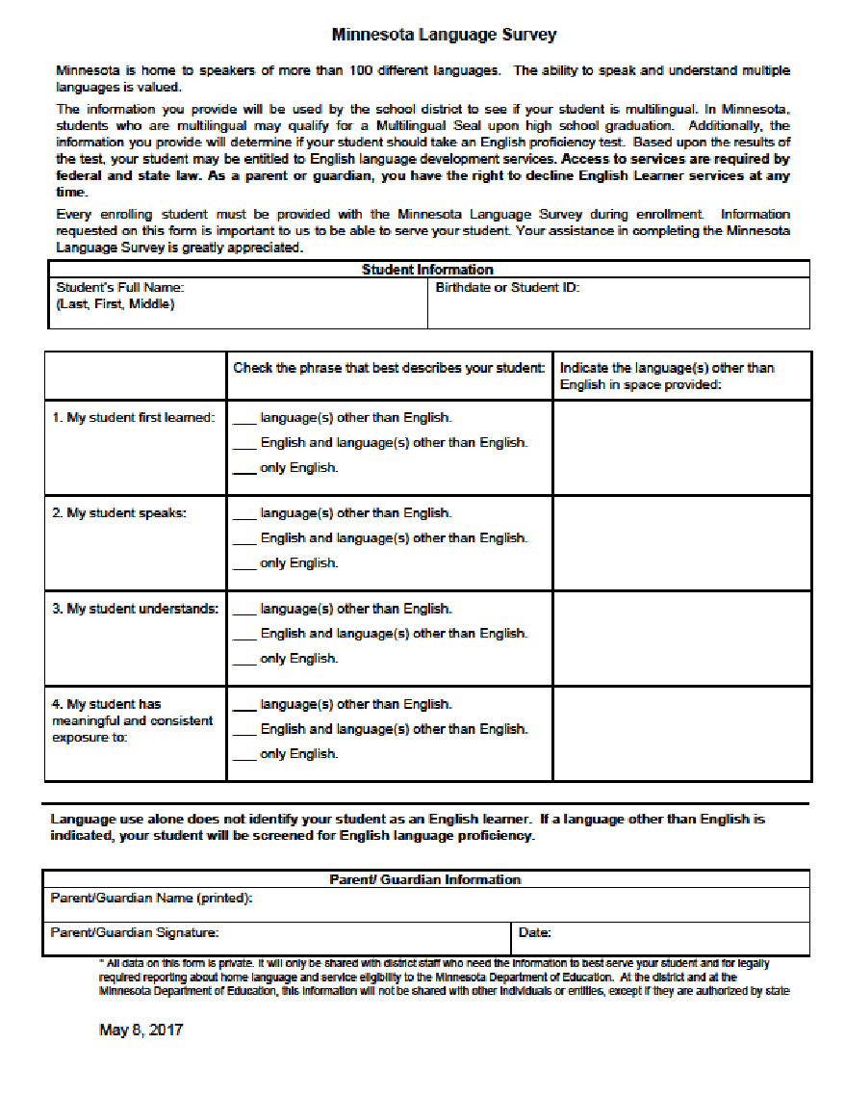

# Appendix B

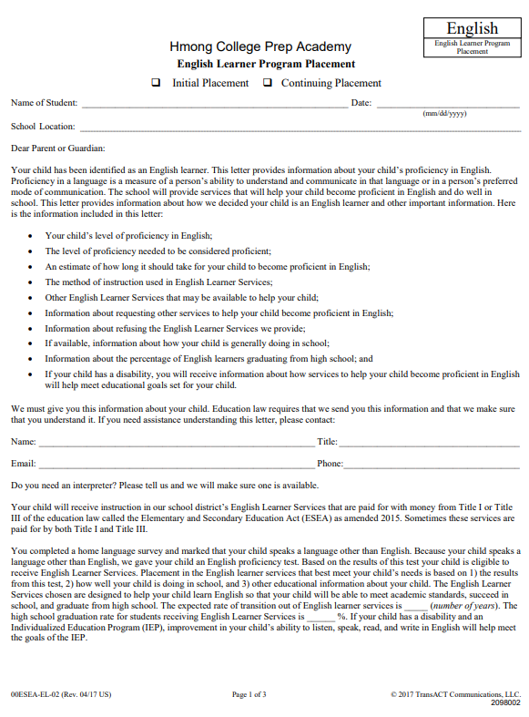

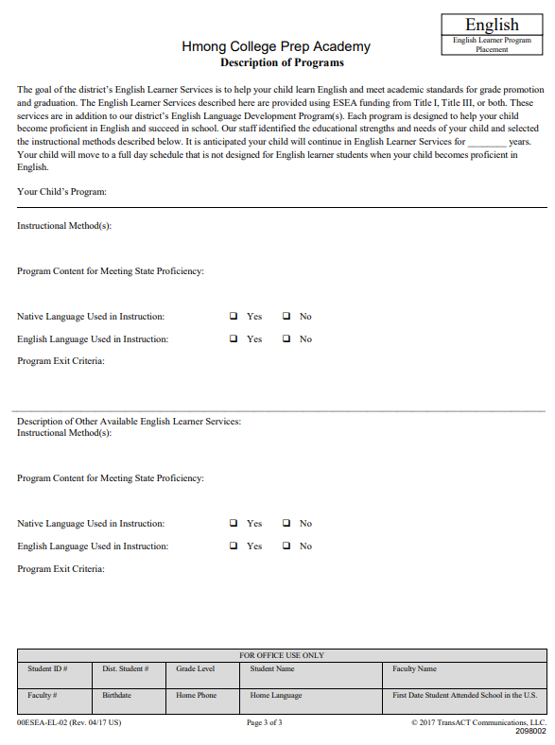

# 

# Appendix C

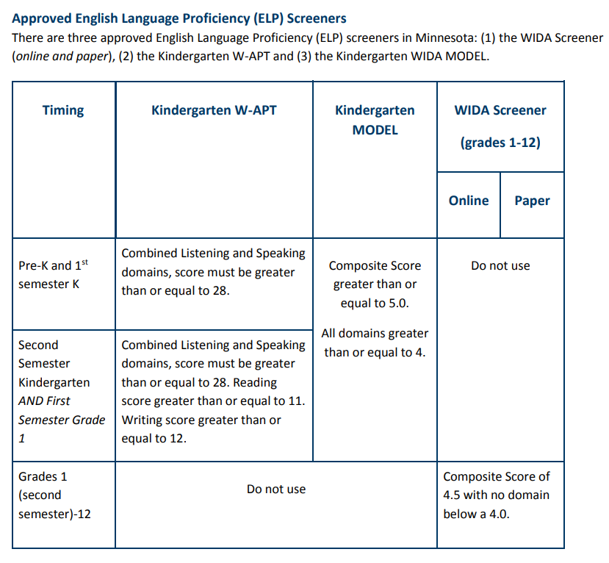[4]

# 

# Appendix D

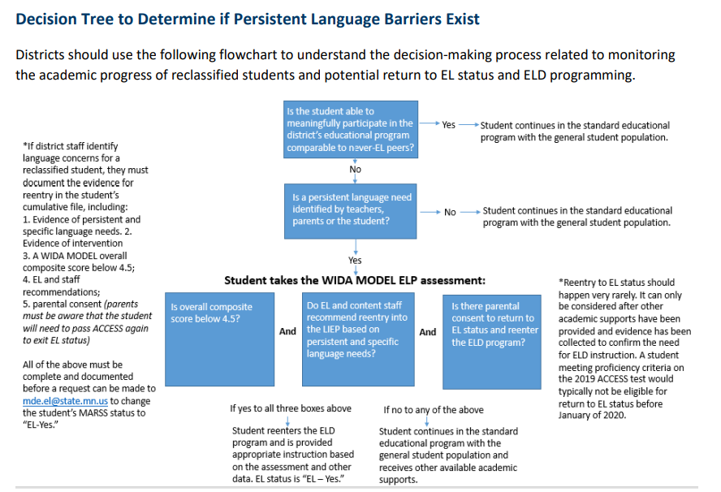

# Appendix E

* 1. List of Exited Monitoring Students is compiled
     1. List of Exited students who still need to be monitored is generated by MARSS Coordinator and sent to EL Leads
     2. Leads create a Google Sheet for current school year
  2. Responses are collected at the end of each semester
     1. Google forms for each individual student are created
     2. Forms are sent to every teacher who has contact/provides services to the student
     3. Responses are collected and recorded on School Year Google Sheet
  3. Responses are evaluated
     1. If no ‘flags’ are found based on answers, no actions are taken
     2. If one flag, comments are noted from the teacher who indicated a concern, but no further actions are taken
     3. If two flags, then the student will be reassessed for ELL services.
  4. If student is indicated to need to be reassessed, the below actions must be followed before the student can be re-enrolled in the EL program
     1. Students take the WIDA Screener again. If composite score is below 4.5, then the re-identification process proceeds
     2. EL and content staff provide feedback on whether the student has exhausted all other academic support or if EL services would be a better fit. If recommended, re-identification process proceeds
     3. Parent must provide consent before student can be re-identified as EL
  5. Student is re-enrolled as an EL Identified student

# 

# 

# 

# 

# 

# 

# 

# 

# References

1. Copyright 2022. Professional Learning for Educators. Lexia LETRS. <https://www.lexialearning.com/letrs>
2. Copyright 2023. Minnesota Department of Education. English Learner Education. <https://education.mn.gov/mde/dse/el/>
3. Copyright 2023. The Society for Industrial and Organizational Psychology. SIOP Strategies. <https://www.siop.org/>
4. Copyright 2023. TransACT Communication System. TransACT Parent Notices. <https://www.transact.com/>

1. <https://www.revisor.mn.gov/statutes/cite/124D.59>
2. [2021-22 English Learners in Minnesota Report](https://education.mn.gov/mdeprod/idcplg?IdcService=GET_FILE&dDocName=PROD069879&RevisionSelectionMethod=latestReleased&Rendition=primary)
3. [Minnesota Standardized Language Procedures](https://education.mn.gov/mdeprod/groups/educ/documents/hiddencontent/bwrl/mdcy/~edisp/mde072445.pdf)
4. [Using ELP Screeners in MN](https://wida.wisc.edu/sites/default/files/Website/State%20Pages/Minnesota/Using-ELP-Screeners-in-MN.pdf)